Research Article

Diversity of Bee Floral Resources and Honey Production

Calendar in Ethiopia’s Southwest Shoa Zone

# Introduction

Ethiopia is renowned for its high diversity of plant species [1, 2] and is a significant center of origin for many endemic plant species [3]. Out of the country’s 6,000 species of higher plants, 647 (10.74%) are endemic [4]. Understanding the primary bee plant species and their flowering calendar in various agroecological zones is crucial for estimating the honey flow period, which is essential for effective beekeeping operations [5]. A flowering calendar provides beekeepers with a timetable that estimates the dates and durations of the blossoming periods of key honey and pollen-producing plants [5]. The flowering calendar and the seasonal cycles of honeybee colonies are interconnected, facilitating efficient seasonal colony management [6]. Beekeeping operations should align with the phenological patterns of local honey plants to ensure that the peak population size of bees occurs before or during the nectar flow, even though bee populations naturally increase when resources are abundant [7].

The variety in geography, climate, and plant habits results in differences in flowering plants, their blooming periods, and nectar secretion potentials across different locations [8]. Consequently, honey flow and dearth seasons vary by region and altitude [9]. Beekeepers can maximize honey and other honeybee products by leveraging their extensive knowledge of the type, density, and quality of bee flora resources [10, 11].

Ethiopia holds significant potential for the growth of beekeeping [12], with the capability to produce 500,000tons of honey annually. However, the current annual honey production is only 10.8% of this potential [13]. This shortfall is primarily due to the inadequate adoption of advanced beekeeping technologies and skills that enhance the quantity and quality of bee products, as well as a lack of information on colony management in relation to blooming calendars [10, 14].

The Oromia region boasts the highest forest coverage among Ethiopia’s nine regions, encompassing 70% of the nation’s forested areas [15]. This extensive forest cover significantly contributes to Oromia’s status as the leading honey-producing region in Ethiopia, accounting for 41% of the country’s honey production [16]. The southwest Shewa zone, similar to other parts of Ethiopia, shows great promise

|  |
| --- |
| 37  °48´0˝E  37  °48´0˝E  38  °6´0˝E  38  °6´0˝E  8  °24´0˝N8°42´0˝N  8  °24´0˝N  8  °42´0˝N  FIGURE 1: Map of the study area.  ðaÞ ðbÞ ðcÞ  FIGURE 2: (a and b) Modern bee hive fitted with pollen trap and (c) sorted pollen into homogenous color. |

for honey production. Notably, Erica arborea honey, a distinctive variety, is produced in the area around Wonchi lake [17].

# Materials and Methods

2.1. Description of the Study Area. The research took place in the southwest Shoa zone, Oromia region, Ethiopia (Figure 1). Three districts were included in the study—Waliso, Amaya, and Wonchi. Within each district, three specific sites were chosen based on their respective agroecologies. These districts encompass diverse geographic features, including highlands, midlands, and lowlands. They are also characterized by a variety of natural vegetation and cultivated crops, including horticultural produce suitable for beekeeping, oilseeds, grains, and legumes.

9403, 2024, 1, Downloaded from https://onlinelibrary.wiley.com/doi/10.1155/2024/5428576, Wiley Online Library on [09/09/2024]. See the Terms and Conditions (https://onlinelibrary.wiley.com/terms-and-conditions) on Wiley Online Library for rules of use; OA articles are governed by the applicable Creative Commons License

2.2. Data Collection

2.2.1. Establishing Colonies and Gathering Pollen Loads. After standardizing all honeybee colonies, a randomized sampling approach was employed to allocate colonies for honey and pollen collection. A total of 36 honeybee (Apis mellifera L.) colonies were established across nine locations spanning three districts within the southwest zone. Each site hosted two colonies dedicated to honey production and two for pollen collection. Additionally, honey samples were gathered from beekeepers. Twelve colonies (six for pollen collection (Figure 2(a)) and six for honey production) were utilized per district. Increasing the number of honeybee colonies did not yield significant additional insights due to consistent floral resources in similar locations. The types of honey and pollen vary seasonally across different agroecologies, influenced by varying flowering plants. A pollen trap with 16% effectiveness was installed at each colony entrance. The pollen trap was designed to collect the pollen pellets from the hind legs of foraging bees without causing them harm. The trap was checked to ensure that it was functional and correctly positioned to collect sufficient pollen loads over the desired period. Pollen loads were collected every 5 days and stored at hive temperature until analysis (Figure 2(b)). Pollen loads were categorized by color (Figure 2(c)). A small quantity of the collected pollen loads was placed in a clean slide. A few drops of 70% ethanol were added to facilitate homogenization and prevent clumping. The pollen was gently mixed with a sterile spatula. A small amount of the homogenized pollen mixture was then transferred onto a microscope slide. A drop of distilled water was added to the pollen on the slide, and the pollen pellets were gently teased apart with a fine needle or dissecting probe. A drop of glycerin jelly was added to mount the pollen grains, preserving them and providing a clear background for observation. Finally, a coverslip was carefully placed over the mounted pollen, ensuring that no air bubbles were trapped by gently lowering the coverslip at an angle.

2.2.2. Honey Pollen Analysis. A total of 36 honey samples were collected during the honey harvesting seasons for pollen analysis. Each honey type was represented by three samples taken from established honeybee colonies. Each sample weighed ~500 g and was stored at a temperature of 4°C for further examination. Pollen slides were prepared according to the procedures described by Louveaux et al. [18] to analyze the botanical composition and frequency of pollen grains present in the honey.

2.2.3. Pollen Grains. To analyze the pollen grains, pollen grains were carefully collected from the anthers of flowers and kept in individual envelopes to avoid contamination. For light microscopic preparations, ripe pollen grains were shaken directly onto microscope slides. To enhance the transparency of the pollen grains, the fat content was washed out using ether to improve the clearness of the pollen grains, ensuring that any large and visible foreign particles were removed before adding glycerin. The slides were then covered with cover slips using warm glycerin jelly. The cover slips were gently pressed together to get a uniform and thin layer of glycerin jelly. Finally, the cover slips were sealed with clear nail varnish. Finally, photo of the pollen archived and used for honey source identification.

9403, 2024, 1, Downloaded from https://onlinelibrary.wiley.com/doi/10.1155/2024/5428576, Wiley Online Library on [09/09/2024]. See the Terms and Conditions (https://onlinelibrary.wiley.com/terms-and-conditions) on Wiley Online Library for rules of use; OA articles are governed by the applicable Creative Commons License

2.2.4. Inventory of Bee Forage Plants. Inventorying bee forages began with a thorough 2-year survey and observation of nearby flora to assess their attractiveness to honeybees for nectar and pollen collection. Pollen traps were strategically positioned at the same location year-round, complemented by honey pollen analysis for validation. Following this preliminary phase, a comprehensive plant inventory was undertaken to catalog the bee-attracting plant species in the vicinity.

Transect lines extending north, south, west, and east within a 2 km radius (2 km is economic flight range of honey bees) from apiary sites were established using GPS compasses to ensure directional accuracy. This survey aimed to assess both the quantity and diversity of available bee forage. Apiary sites were strategically spaced within a maximum radius of 6 km to avoid competition and resource overlap.

Within each transect, 20 m × 20 m plots were demarcated at 400 m intervals, as illustrated in Figure 3. Each large plot was subdivided into five 2 m × 2 m (4 m2) subplots to facilitate meticulous counting of grasses and herbaceous species. The identification of all bee forage plant species within each sample plot was meticulously conducted. For plants challenging to identify in the field, standard herbarium methods were employed to collect specimen samples, which were later identified at Holeta Bee Research and the National Herbarium of Addis Ababa University.

2.2.5. Data Analysis. Descriptive statistics were employed for data analysis. Principal component analysis (PCA) was utilized to categorize monofloral honey using the R software. The diversity of bee plants was assessed using the Shannon–Wiener index.

s

|  |
| --- |
| 400  m  400  m  Apiary  N  W  E  S  400  m  400  m  400  m  m  400  m  400  400  m  20  m  20  m  1  1  1  1  1  m  20  m  20  ðaÞ ðbÞ  FIGURE 3: (a) Lay out of bee plant inventory and (b) main plot and subplot. |

where H′ is the Shannon–Wiener diversity index, Hmax is the maximum value of Shannon–Wiener diversity index, and J is the evenness, the value of J ranges from 0 to 1. Higher values indicate higher levels of evenness. At maximum evenness, J = 1.

The relative abundance of bee flora was calculated as the following:

Abundance (A): number of respective tree species divided by extent of sampling area.

Relative abundance (RA): abundance of respective plant species divided by total abundance of all plant species and times 100.

# Results and Discussions

3.1. Identified Bee Forage Plants and Their Abundance. In a recent field inventory across Waliso, Amaya, and Wonchi districts, a total of 122 plant species were identified as significant bee foraging sources (Table 1). Notably, Guizotia scabra (12.08%), Eucalyptus camaldulensis (10.06%), and Vernonia auriculifera (9.33%) were the most abundant bee forage plants in Waliso district. Meanwhile, Euclea schimperi (18.09%) and E. camaldulensis (15.49%) dominated in Amaya district. In Wonchi district, V. auriculifera (8.77%), Rumex nervosus (6%), E. camaldulensis (5.44%), G. scabra (4.5%), and E. arborea (4.32%; Figure 4) were identified as dominant bee forage species.

Across the three districts, 46 plant species (37.40% of the total) were found common, including Acacia abyssinica, Achyranthes aspera, Agave sisalana, Bersama abyssinica, Coffea arabica, Cordia africana, and Croton macrostachyus, indicating a broader ecological distribution compared to other species in the area.

Shrubs (44.26%) and trees (27.87%) were the most prevalent life forms among the identified plants, while climbers (7.38%) were the least prevalent (Table 1). This distribution contrasts with findings from the Boda dry evergreen Montane Forest in West Showa, Ethiopia, where trees constituted 34.7%; shrubs, 45.2%; and various other forms made up the remainder [23]. In southwestern Ethiopia, another study showed that honeybees relied on herbs (36.6%), shrubs (25.8%), trees (23.6%), and climbers (14%) for their primary food sources [24]. These differences highlight how the composition of bee plant species varies across locations based on ecological conditions and vegetation disturbance.

9403, 2024, 1, Downloaded from https://onlinelibrary.wiley.com/doi/10.1155/2024/5428576, Wiley Online Library on [09/09/2024]. See the Terms and Conditions (https://onlinelibrary.wiley.com/terms-and-conditions) on Wiley Online Library for rules of use; OA articles are governed by the applicable Creative Commons License

The study underscores that vegetation diversity can vary significantly; high diversity occurs when numerous species are evenly distributed, whereas low diversity results from few species with uneven distribution [25].

3.2. Diversity of Bee Flora Resources in the Study Districts. The highest species diversity (H′ = 4.70) and species richness (92) were recorded in Wonchi district, with Waliso district following closely (Table 2). However, Waliso district exhibited the greatest Shannon evenness (E). Generally, species richness and diversity tend to be higher in conserved natural forests compared to deforested areas because undisturbed environments allow plant species to regenerate naturally. For instance, Wonchi district, which encompasses the natural forest surrounding Wonchi Crater lake, boasts higher species diversity and richness than other districts. This lake is situated at altitudes ranging from 2,800 to 3,200 m above sea level. Furthermore, the study areas spanned altitudes from 2,200 to 3,200 m above sea level, highlighting the district’s varied agroecology. High plant diversity indicates a robust ecosystem capable of withstanding unforeseen environmental changes.

The results of the current study align with previous research, which has demonstrated that species richness and diversity vary with altitude, peaking at intermediate altitudes and decreasing at both lower and higher elevations [26]. Amaya district, predominantly used for agriculture, exhibited lower bee plant species diversity, richness, and evenness than the other districts. A comparable study in the protected landscape of the Philippines reported the highest species diversity at H′ = 3.77 [27], which is lower than that found in our study area. Plant diversity is influenced by topographic variables such as slopes, aspects, and altitude [28].

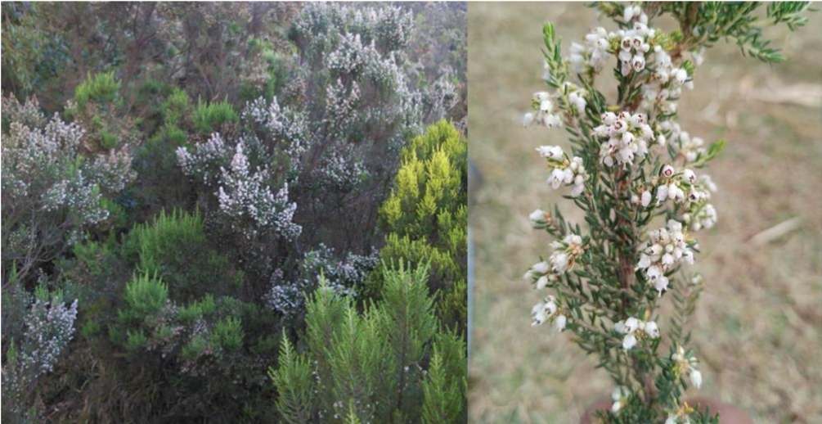

FIGURE 4: Erica arborea and its flowers around Wonchi Creator lake in southwest Shoa, Ethiopia. (These pictures were taken during plant inventory around the lake).

TABLE 1: Diversity indices of the bee flora resources for Waliso, Wonchi and Amaya districts in southwest Shoa, Ethiopia.

|  |  |  |  |
| --- | --- | --- | --- |
| District | Species richness | Shannon’s diversity index (H′) | Shannon evenness (E) |
| Waliso | 86 | 4.55 | 0.59 |
| Wonchi | 92 | 4.70 | 0.58 |
| Amaya | 71 | 4.08 | 0.53 |

The biodiversity value of any area is typically assessed in terms of species richness [27].

3.3. Flowering Period of Major Bee Forages in Waliso, Amaya, and Wonchi Districts. Bee plant species have varying flowering times, depending on the duration of the rainy season. For instance, bee forage plants that bloom from September to November are expected to yield honey by late November or early December. Honey harvested around this time is derived from plants such as G. scabra, H. forskaolii, Bidens species, Trifolium species, and C. africana (Table 3). Conversely, bee forage plants that flower from April to May produce honey by late May or as late as mid-June, again depending on the rainy season’s timing. For instance, in June, honey is produced by C. macrostachyus and some Eucalyptus species (Table 3). A study conducted in Gera, southwestern Ethiopia, found that 81% of bee plants flowered between September and November, 10.8% between

March and May, and a small percentage between December and February [5].

3.4. Pollen Load Analysis. Based on the analysis of pollen loads, 31 significant pollen source plants were identified. Among these, Bidensprestinaria, E.camaldulensis, E.globulus,G.scabra, P.lanceolata, Mesea lanceolata, Trifolium species, and Vernonia species were most frequently visited by honeybees for pollen, with visits spanning over 50 days. Plants such as E. macrochaetus, Maytenus obscura, V. faba, Apodytes dimidiata, C. abyssinica, H. abyssinica, and Terminalia schimperiana were moderately visited for pollen for 30–45 days.

3.5. Seasonal Availability of Pollen. Throughout the year, the fresh weight of pollen collected exhibited considerable variation in peaks; however, significant amounts were consistently gathered in almost all districts during September, October, November, April, and May. These findings align with previous studies that indicate that the seasonal variations in pollen availability are common due to the differing flowering periods of plants [30, 31].

Depending on the rainfall, honey can be harvested at the end of November or the beginning of December and again at the end of May or the beginning of June. This seasonal harvesting schedule is consistent with the work of Thompson and Hunt [32], who found that honey production is closely linked to rainfall patterns and floral abundance.Conversely, February, March, July, and August exhibited minimal bee foraging activity across all three districts,

0

100

September

October

November

December

January

February

Months

Waliso

Wonchi

Amaya

March

April

May

June

July

August

200

Pollen yield (g)

300

400

500

600

FIGURE 5: Monthly pollen gathered from Waliso, Amaya, and Wonchi districts.

9403, 2024, 1, Downloaded from https://onlinelibrary.wiley.com/doi/10.1155/2024/5428576, Wiley Online Library on [09/09/2024]. See the Terms and Conditions (https://onlinelibrary.wiley.com/terms-and-conditions) on Wiley Online Library for rules of use; OA articles are governed by the applicable Creative Commons License

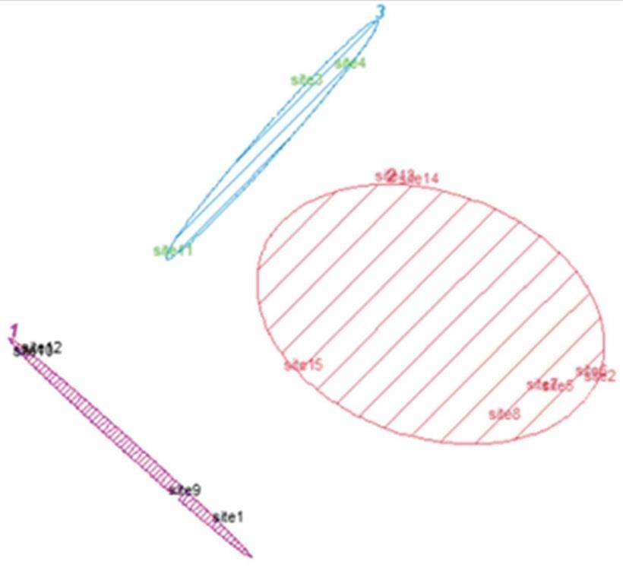

–50

–50

0

50

0

50

Component 2

Component 1

*Guizotia*

honey

*Eucalyptus*

honey

*Erica*

honey

100

FIGURE 6: Monofloral honey types from southwest Shoa zone.

indicating that supplemental feeding is essential during periods of low floral availability to maintain colony health and productivity [33].

The following graphs (Figure 5) illustrate the periods of highest pollen availability, followed by medium, low, and no pollen at all, across each district in the study areas. These data are utilized to manage honeybee colonies throughout the year, indicating optimal times to add supers, reduce supers, harvest honey, and provide additional food resources. Managing bee colonies based on pollen availability is a welldocumented practice, with studies showing that strategic management can significantly enhance colony health and honey production [34, 35].

3.6. Honey Harvesting Calendars. Three honey harvesting periods were identified in the study areas—November, January, and June. Two monofloral honeys, Eucalyptus and Erica, come from woody plants. Research in southwestern Ethiopia supports this, with 86.7% of monofloral honey from woody plants and only 13.3% from weeds and crops [36].

In Wonchi district, Erica honey is the sole type produced, whereas Guizotia and Eucalyptus honeys are produced in all the districts covered by the study. Different bee forage plants contributed to each monofloral honey during these seasons (Table 5). For November honey production, the majority (50%) of the contributing bee plants were herbaceous (Table 5). Conversely, shrubs played a larger role in the production of January honey (Table 5). The frequency and timing of honey harvesting vary from place to place depending on the types of bee forage plants available. For instance, in Gera, southwestern Ethiopia, honey can be harvested four times a year [5], while in the Guji zone, it can be harvested up to three times annually [7]. In the Borena zone of southern Ethiopia, honey production occurs once or twice a year [11], depending on rainfall availability.

9403, 2024, 1, Downloaded from https://onlinelibrary.wiley.com/doi/10.1155/2024/5428576, Wiley Online Library on [09/09/2024]. See the Terms and Conditions (https://onlinelibrary.wiley.com/terms-and-conditions) on Wiley Online Library for rules of use; OA articles are governed by the applicable Creative Commons License

3.7. Honey Pollen Analysis. PCA clustering of pollen percentage counts identified three distinct types of monofloral honey in the study area—G. scabra, E. arborea, and E. camaldulensis (Figure 6). Guizotia and Eucalyptus honeys dominate regions with extensive cultivation, while Erica honey is unique to Haro Wonchi in the Wonchi district.

Honey pollen analysis identified 35 plant species as honey sources (Table 6). Major sources contributing over 45% of total pollen content include G. scabra, E. camaldulensis, and E. arborea, aligning with previous studies on their abundant floral resources and bee attractiveness.

Guizotia species, known for prolific flowering and high nectar yield, are major pollen and nectar sources for honeybees, producing high-quality honey [37]. Eucalyptus species are major nectar sources globally due to their adaptability and extended flowering periods [38]. E. arborea, significant in Mediterranean and African regions, attracts bees with its extended blooming season and high pollen and nectar yield [39].

Secondary pollen sources (16%–45% pollen count) include C. macrostachyus, B. carinata, H. triflora, and C. africana, essential for sustaining honey production and bee health [40].

G. scabra was the main honey source in most study districts in October and November, Eucalyptus species in June in Amaya and Waliso districts, and E. arborea in December at Haro Wonchi in Wonchi district. In other Wonchi district areas, G. scabra was primary, followed by E. camaldulensis for June honey production. G. scabra monofloral honey is widely produced in Ethiopia’s Oromia region, including Borana zone (Abbaya, Dugda Dawwa, and Teltelle districts) and Guji zone (Adola Redde district) [11].

3.8. Microscopic Photograph of Pollens for Some Major Bee Plants. The pollen shape is a crucial factor in identifying the botanical source of honey and honeybee-collected pollen. In the study area, specific pollen shapes corresponding to major

9403, 2024, 1, Downloaded from https://onlinelibrary.wiley.com/doi/10.1155/2024/5428576, Wiley Online Library on [09/09/2024]. See the Terms and Conditions (https://onlinelibrary.wiley.com/terms-and-conditions) on Wiley Online Library for rules of use; OA articles are governed by the applicable Creative Commons License

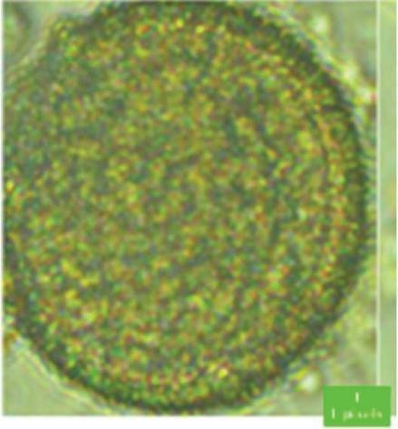

ð

a

Þ

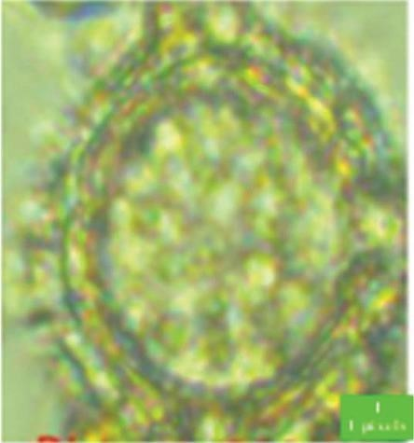

ð

b

Þ

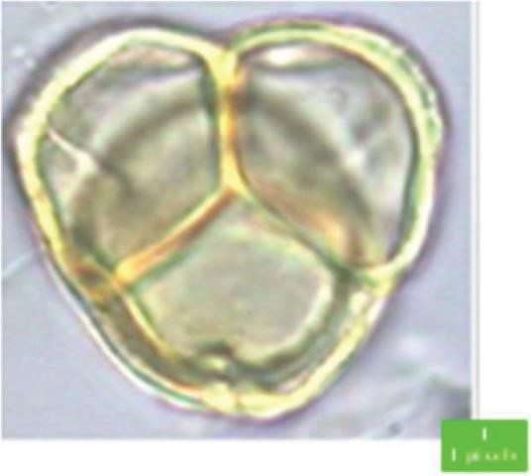

ð

c

Þ

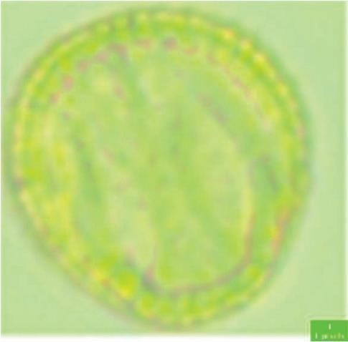

ð

d

Þ

FIGURE 7: Pollen pictures of some major honey flora that are identified in the study area. (a) C. macrostachyus Hochst. ex Delile, (b) V. amygdalina Delile, (c) E. arborea L., and (d) B. carinata A.Braun.

bee forage plants were identified, facilitating the determination of the plant species visited by bees. This method of botanical source identification is supported by previous research, which has consistently demonstrated the importance of pollen morphology in melissopalynology (the study of pollen in honey; Figure 7).

A relevant study by Sawyer [41] highlights the significance of pollen shape and size in identifying plant species in honey samples. Sawyer’s work established a comprehensive reference for pollen morphology, which has been widely used in subsequent research for identifying botanical sources of honey. Additionally, Jones and Bryant [42] provided a detailed analysis of pollen grains from various plants, emphasizing the distinctive characteristics such as shape, size, and surface texture that aid in accurate identification.

# Conclusion

The study identified 122 plant species through plant inventory, honey pollen analysis, and pollen load collection. The Wonchi district exhibited the highest diversity of bee forage plants, followed by Waliso. The research also identified three honey harvesting calendars. Three types of monofloral honey are produced in the area—Guizotia honey in November, Erica honey in January, and Eucalyptus honey in June. There is a shortage of bee forage in February, March, July, and August across all districts in the study area, necessitating supplementary feeding during these months. Overall, the available bee flora resources indicate that the southwest Shoa zone (Wonchi, Waliso, and Amaya districts) has significant potential for sustainable and commercial beekeeping. To ensure sustainability, it is crucial to preserve existing bee flora and promote the cultivation of multipurpose plant species. Additionally, increasing awareness through farm demonstrations on the importance of floral and honey calendars is recommended to enhance the management of honeybee colonies and boost honey harvest frequency.

# Data Availability

The data that support the findings of the study are available from the corresponding author upon the reasonable request.

9403, 2024, 1, Downloaded from https://onlinelibrary.wiley.com/doi/10.1155/2024/5428576, Wiley Online Library on [09/09/2024]. See the Terms and Conditions (https://onlinelibrary.wiley.com/terms-and-conditions) on Wiley Online Library for rules of use; OA articles are governed by the applicable Creative Commons License

Conflicts of Interest

The authors declare that they have no conflicts of interest.

# Acknowledgments

The authors are thankful to the Holeta Bee Research Center and Oromia Agricultural Research Institute for providing the required facilities and logistics. We also like to express our gratitude to Konjit Asfaw for supporting us in the laboratory, Tesfaye Abera, Birhane Tadese, Kibbu Wakjira, and Bekele Gemechu for their fieldwork assistance. The study was funded by Ethiopian Government (no specific grant number).